**PERFORMANCE MANAGEMENT POLICY**

# TABLE OF CONTENTS:

1. **OBJECTIVE**
2. **SCOPE**
3. **PURPOSE**
4. **APPRAISAL CYCLE TIMELINE**
5. **IMPORTANCE OF ALTRAN ANNUAL APPRAISAL**
6. **PERFORMANCE MANAGEMENT PROCESS**
7. **PERFORMANCE APPRAISAL STEPS**
8. **RATING SCALE AND RATING DESCRIPTION**
9. **CAREER PATHS**
10. **IDENTIFYING AND MANAGING POOR PERFORMERS**
11. **PROCESS TO HANDLE POOR PERFORMERS**
12. **DISCLAIMER**

|  |  |  |  |  |
| --- | --- | --- | --- | --- |
| **DOCUMENT REVISION HISTORY** | | | | |
| **Version Number** | **Modified Date** | **Modified By** | **Changes** | **Approval Authority** |
| 1.0 | 01/01/2018 | HR Operations | Introduced the policy | Head, HR |

1. **OBJECTIVE**

To develop a framework to carry out a fair & effective performance management program that is aligned to the business goals.

# SCOPE:

Applicable to full time employees of Altran India Pvt Ltd.

# PURPOSE

The purpose of performance management process is to create a valuable opportunity for managers and employees to have time out for one on one discussion to focus on goal setting competencies assessment and development plan for the new year. This is also an opportunity for performance assessment, competency review, and development planning for the past years. It also is the time to review career goals for the future.

# APPRAISAL CYCLE TIMELINE

Altran follows annual appraisal cycle between January to December. Any employee who has joined on or before 30th September are covered under AAA.

# IMPORTANCE OF ALTRAN ANNUAL APPRAISAL (AAA)

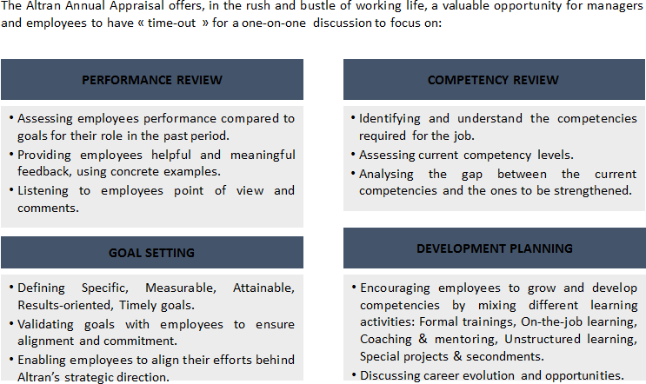

1. **PERFORMANCE MANAGEMENT PROCESS**

Altran Performance Management Program will include 5point- Rating scale review process. Manager assess the employees overall performance in the Altran Appraisal form followed by rating in the TMS tool.

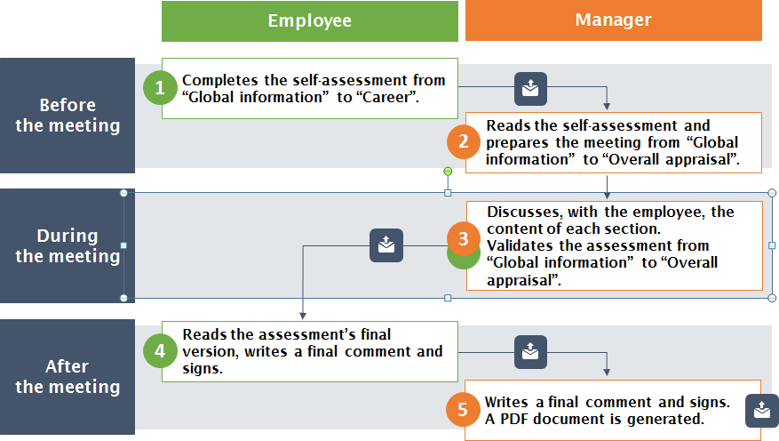

# PERFORMANCE APPRASIAL STEPS

Below are the steps to be followed in the entire Performance Management Program.

|  |  |  |
| --- | --- | --- |
| **Step/Activity** | **Activity Detail** | **Responsibility** |
| **Self-assessment for the current year & Goal setting for the next year** | Employee to complete the self-assessment in AAA form from “Global Information" to "Career". | Employees |
| **Manager Review** | Manager reads the self- assessment in AAA form from "Global information" to "Overall appraisal" | Manager |
| **Appraisal Discussion b/w Employee & the Manager** | After the employee self- assessment, manager discusses with the employee, the content of each section. Validates the assessment from “Global information” to “Overall appraisal | Manager |
| **Employee Acknowledgement** | Employee reads the assessment final version, writes a final comment & sign off. | Employees |
| **Final Rating** | Manager enters the final comment/rating, followed by sign off. | Manager |
| **Calibration** | HRBP handles the calibration at the business level | HRBP/ Business head |
| **Merit Increase/ Promotion** | HR Operations processes the merit increase/ promotions/issues increment letters based on the merit  guideline | HRBP/HR Operations |

The entire Appraisal activity needs to be updated in the Talent Management System (TMS).

# RATING SCALE AND RATING DESCRIPTION

Rating scale is used for performance evaluation is 1 to 5. Rating definition & rating descriptions are given below:

|  |  |  |  |
| --- | --- | --- | --- |
| **Rating** | **Rating Scale** | **Achievement Criteria** | **Rating Definition** |
| **5** | **Exceeds expectations** | Achievement ≥105% | Consistently goes beyond the expected results and the position skills’ requirements. Excels at what he/she does. |
| **4** | **Fully meet expectations** | Achievement ≥95% to <105% | Performs consistently well with regards to the expected results. Fulfils the position skills’ requirements. Can be counted on to get the job done. |
| **3** | **Mostly meet expectations** | Achievement ≥75% to <95% | Performs at expected level most of the time and below expected level at other times. Fulfil most of the position’s skills requirements. Needs an action plan to further develop targeted areas |
| **2** | **Partially meet expectations** | Achievement ≥50% to <75% | Performs at expected level some of the time and below expected level at other times. Fulfil part of the position’s skills requirements. Needs an action plan to improve targeted areas |
| **1** | **Does not meet expectations** | Achievement <50% | Is below standard with regards to the expected results. Does not fulfil the position’s skills requirements. Needs an immediate action plan and/or move to consider. |

# CAREER PATHS

Across global Altran has implemented career path with the below objectives. In order to meet the Group’s development objectives.

* + Strengthen our capability to manage customer projects and to intervene on more complex and strategic topics that require more specialized expertise and focus.
  + Better visibility and better development opportunities
  + In response to what is expressed by our customers and partners to have more multidisciplinary and international teams.
  + Our HR policy is changing career paths are a concrete illustration of this change.
  + Among the four top priorities of C.A.R.E., Career paths are designed to recognize and develop the expertise of our talents.
  + Career path structure is provided as below:

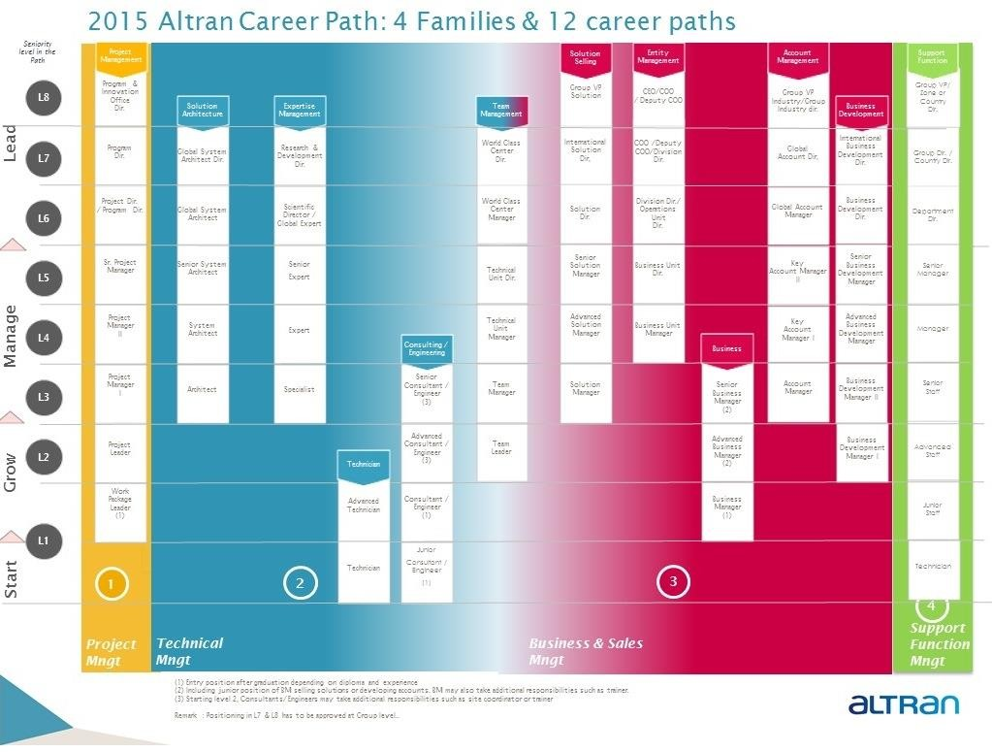

# IDENTIFYING AND MANAGING POOR PERFORMERS

The objective is to provide a guideline and action plan for employees who are poor performers as per appraisal ratings. Timeline for Performance Improvement Plan (PIP) is Minimum 30 and Maximum 90 calendar days. If the performance does not improve by the end of review period, PIP can be extended by a month at manager/HRBP discretion.

# PROCESS TO HANDLE POOR PERFORMERS

* Manager needs to identify the poor performer & develop a PIP plan. Employees with poor performance are put under PIP for duration of 1 to 3 months.
* Goals to be specific, measurable and realistic and to be contained within the target review period.
* Manager needs to discuss the plan with HRBP.
* Meeting to be organized by the manager with the employee in presence of the HRBP to explain the PIP plan to employee
* Manager to issue the PIP and take a sign-off on the PIP issuance form followed by
* Monthly Interim reviews
* If required, PIP can be extended for additional (maximum) 30 days from end of review period date. Manager and HRBP to issue Extension Letter to the employee.
* In case of the improvement of the performance, HRBP closes the PIP. If the performance does not improve, termination process will be initiated.

# Annexures to the PIP : Refer to the ESS Portal

* PIP Form
* PIP completion Form



PIP Form.docx PIP_Completion_For

m.docx

# DISCLAIMER

This policy and its contents are confidential and intended solely for the use by employees of Altran Technologies India Pvt. Ltd. Transmitting, Disclosing, Copying, distributing these content to other than the intended recipient / users is strictly prohibited. It is the sole discretion of the Management to change, amend the entire policy and/or its clause/s from time to time and/or withdraw the same, without any notice. This policy supersedes all earlier versions if any.